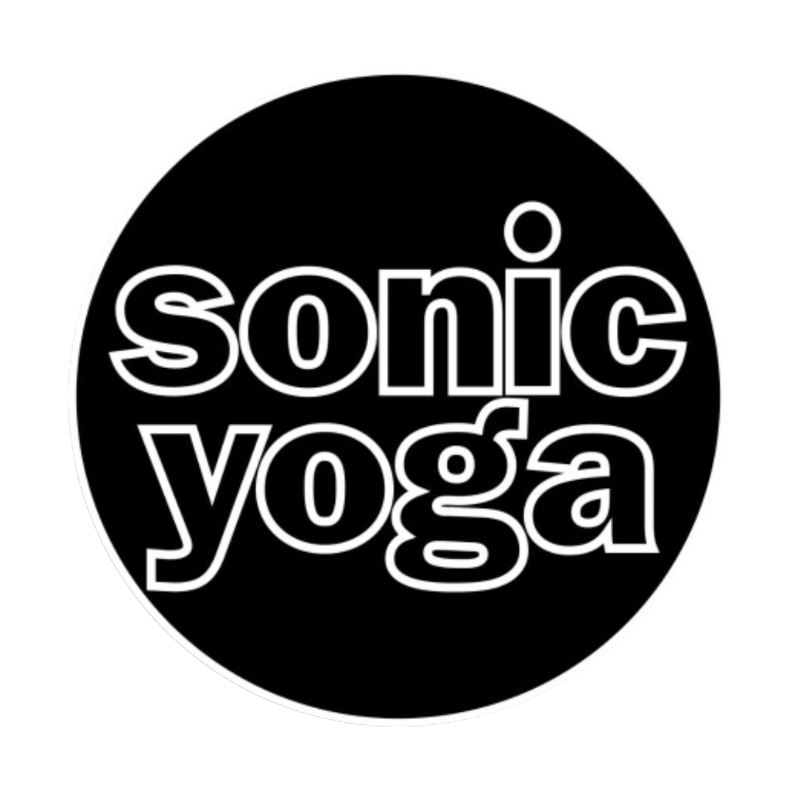

Hello Dear Yogi!
Thank you for your interest in the SONICYOGA 200 Hour Teacher Training Program! We are excited to welcome you into our Yoga community.
We are proud to be a 4.85 star rated Yoga Alliance School with a teacher training staff with over 70 years combined teaching experience.

FALL/ WINTER 2026-27 IN-STUDIO DATES:

- OCTOBER 17th & 18th, 24th & 25th, 31st

- NOVEMBER 1st, 14th & 15th
- DECEMBER 5th & 6th, 12th & 13th

- JANUARY 9th & 10th

Held in-person, in-studio from 9am to 6pm on Saturday & Sunday.
In addition to the 7 in-studio modules, the following virtual sessions are required:

● Thursday Practicum Sessions from 7:30pm to 9:30pm, virtual (except 2 in-person sessions).

● Tuesday Meditations Sessions from 7-8pm, virtual.

● 4 virtual check-ins to answer questions you may have about your progress or the program, also virtual.

Other Requirements:

- Read, discuss and write a report on The Yoga Sutras of Patanjali
- Read, discuss and write a report on The Bhagavad Gita
- Read, discuss and utilize The Key Poses of Yoga: Scientific Keys, Volume II - Ray Long

- Attend 13 in-studio classes

- Attend 4 Master Classes (8 hours)

- Complete 8 hours of in-studio class observation

- Present a detailed plan of your sadhana, or daily home practice, post training

- Present a detailed plan for a karma or volunteer project, which offers yoga to a group or situation which would benefit

- Pass the Anatomy Exam

- Pass the Yoga from the East Exam

- Teach a Yoga class for Final Practicum

TUITION is as follows:

A non-refundable deposit of $1000.00 is required before the start of the program.

The 200 Hour Teacher Certification Program: $3499.00
Payment plans are available on a case by case basis.

Early Bird Pricing: 200 Hour Teacher Certification Program paid in full by set date is $2999.00
$500 discount if paid in full by September 30, 2026

Unlimited access to in person and virtual yoga classes is included with your deposit.
Please see your contract for terms.

Please let me know when we can set up a telephone call or zoom meeting to answer any questions you may have.

Best,
Mitch Hipp
TT Administrator

SONIC YOGA 200 Hour Teacher Training Terms and Conditions

These Terms and Conditions apply to any Yoga Activities (see definition below) purchased from SONICYOGA (“Sonic Yoga” or “Company”) and govern the contractual relationship between you (“You”, “I” or “Student”) and Sonic Yoga with respect to any such Activities.

PARTICIPATION
I understand that if I am paid in full and fulfill all the requirements of the Sonic Yoga Teacher Training Program, including in-class hours, homework, quizzes, book reports and passing both the written and in-class final exams, within 3 months from the program end date, I will receive a letter of certification which can be submitted to Yoga Alliance as evidence that I have completed a 200-hour Teacher Training program. Paying for the program and attending the hours alone does not mean I have completed the program.
I understand that Sonic Yoga reserves the right at any time to ask me to leave the training if the instructor feels that I pose a risk to the physical safety to the instructor or other students or if I am compromising the learning process of the group. Under such circumstances, I understand I will be given a prorated refund, based on the amount of time I have attended.
I understand that Sonic Yoga reserves the right to ask me to leave the program if I am found plagiarizing, if my behavior is disruptive, inappropriate, negatively impacting other student’s learning, is deemed unethical or violates the Yoga Alliance ethical guidelines. Under such circumstances, I understand I will not be refunded any part of my tuition.
I understand that Students are responsible for assessing their own suitability and capability to participate in a Program. All Students should consult their physician regarding their physical fitness level, mental status and any other special conditions they may be working with. It is the Student’s responsibility to assess the risks and requirements of each Program.
I understand that by registering for a Sonic Yoga Program, I certify that I understand that the Company reserves the right to accept or reject any Student as a participant; to expel any participant from the Activity; to make changes to the program whenever the Company deems it necessary for the comfort, convenience, or safety of the Students.
I understand that I must report any disability requiring special attention at the time the reservation is made. Sonic Yoga will make reasonable attempts to accommodate the special needs of disabled participants, but is not responsible in the event it is unable to do so nor responsible for any denial of services by air carriers, hotels, partners, or other independent suppliers.
Sonic Yoga is not responsible for any missed activities due to a participant's inability to participate with the group.

AGE REQUIREMENT
I understand that I must be at least 21 years old to take part in the teacher training. If I am between 18 and 21 years of age, admission may be granted at the discretion of management upon review of application and interview.

CONTENT POLICY
Sonic Yoga reserves the right to change, alter, or amend the daily itinerary and/or curriculum and/or scheduled teacher for any session at any time. Changes can be made for various reasons including teacher availability. No refunds are provided for changes; full cancellation penalties as stated below continue to apply. The Sonic Yoga Teacher Training Department will make its best efforts to communicate these changes to me as soon as possible.

PRICING, DEPOSITS AND CANCELLATION POLICY
A non-refundable $1000 deposit is due upon enrollment to hold your spot. Your payment is due in full by the early registration date in order to receive a discounted rate. Full payment is required 14 days before the start of the program unless a payment plan has been previously arranged. These fees are non-refundable and non-transferable. If you cancel within 14 days before the start of the program or do not attend the program, the entire deposit and program tuition is non-refundable and non-transferable. Once the program begins the program tuition is non-refundable and non-transferable.
I understand that if I cancel my training, I will be charged the monthly rate for any unlimited yoga I received (if unlimited yoga was included in my package). I also understand that any unused free yoga benefit is not redeemable for cash value.

ATTENDANCE AND LATE POLICY
I understand I am required to complete all of the in-studio hours of my training, and to make up any missed time in accordance with the Sonic Yoga Make Up Policy*.
I understand that any missed hours need to be made up within one year of the program end date and that if I do not make up said missed hours in this time frame I will be required to pay in full to retake the training, in order to qualify to receive my certification.
I understand that if I miss over 30 hours, I will receive a non-passing status and will be asked to leave the training. Under such circumstances I understand I will be required to pay in full to retake the training, if I wish to stay in contention for certification.
I understand that if I am 15 minutes late more than twice, on the third occasion I will be asked to leave and will be required to make up the day according to the makeup policy. If I leave 15 minutes early more than twice, on the third occasion I will be asked to leave and be required to make up the day according to the Makeup Policy. In the unlikely event Sonic Yoga needs to cancel a training, a refund will be provided, however, Sonic Yoga is not responsible for any costs incurred for travel arrangements or accommodations related to attendance of said training. It is your responsibility to purchase travel insurance to protect yourself from any loss due to program cancellations, changes or weather delays. We will not, under any circumstance, reimburse you for airfare or ground transfer expenses.

CLASS MAKE UP POLICY
Make Up Options:
Option 1:
Schedule a private session with a teacher at some point during the program. The cost of a private session ranges from $100-$150 per hour
1-hour private = 1-4 hours of missed time
1.5 hour private = 5-6 hours of missed time
2-hour private = 7-8 hours of missed time
2.5 hour private = 9-10 hours of missed time
3 hour private =11-13 hours of missed time
Please note: Only two sessions of private instruction, regardless of hours, are allowable and are subject to teacher availability. The remainder of your missed time will need to be made up in a future training (see Make Up option 2 below). Private make up sessions are only an option during your current training and are not an option once the program is complete.
Option 2:
You may attend the days you missed in an upcoming training within 1 year at no additional charge. If you miss more than 30 hours or more than 1 year passes without making-up your missed hours, you will be required to pay in full to retake the training to be eligible for certification. All make-up attempts in an upcoming training need to be pre-approved and coordinated via the Sonic Yoga Teacher Training Department.

Release and Waiver of Liability; Assumption of Risk, and Indemnity Agreement
I understand that Sonic Yoga, Inc. is here to serve me by sharing knowledge of yoga and any related activities to promote exercise and good health (“Yoga Activities”). In connection with my participation in the Yoga Activities, I understand, acknowledge and agree as follows:
Participation in the Yoga Activities is completely voluntary and it is solely my decision to participate in such activities.
The practice of yoga involves physical movement and exercise which may from time to time be strenuous, and that such practice carries some risk of injury. I am qualified, in good health and in proper physical condition to participate in the Yoga Activities. I understand that I must judge my own capabilities with respect to practicing yoga at Sonic Yoga and will only participate in the appropriate level of classes (Level 1, Level 2, etc) that are within my limits and capabilities. I acknowledge that it is my sole responsibility to confirm that there is no medical or other reason preventing me from participating in the Yoga Activities. If I am pregnant, I shall only participate in the Yoga Activities after I have discussed the potential risks with my obstetrician. I shall follow my obstetrician’s advice and instructions about whether and to what extent I can participate in the Yoga Activities. I agree that I (and my spouse/partner, heirs, and guardians) will hold Releasees harmless for any possible injury to myself, my spouse/partner, heirs, guardians and/or my child/fetus.
If I believe any conditions are unsafe, I will immediately discontinue participation in the Yoga Activities.
It is my responsibility to inform the instructor immediately if an injury occurs in connection with the Yoga Activities.
From time to time during Yoga Activities, instructors may physically adjust a student’s form. If I do not want such physical adjustments, I will inform the instructor at the beginning of each session that I attend. I also acknowledge that if I do wish to receive such physical adjustments, it is my responsibility to inform the instructor when I believe an adjustment has gone as far as I desire at that time.

Signed,

_____________________ ____________________
Print Name Date

_____________________
Signature

